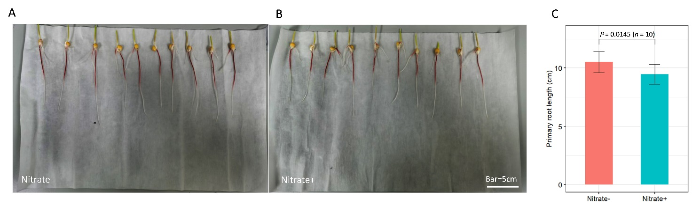

**Fig. S1** – **Phenotype of seedling used for performing scRNA-seq.**

(A, B) Seedling grown on media with nitrate (A) or without nitrate (B). (C) Bar chart showing difference in primary root lengths of seedlings grown under two conditions.

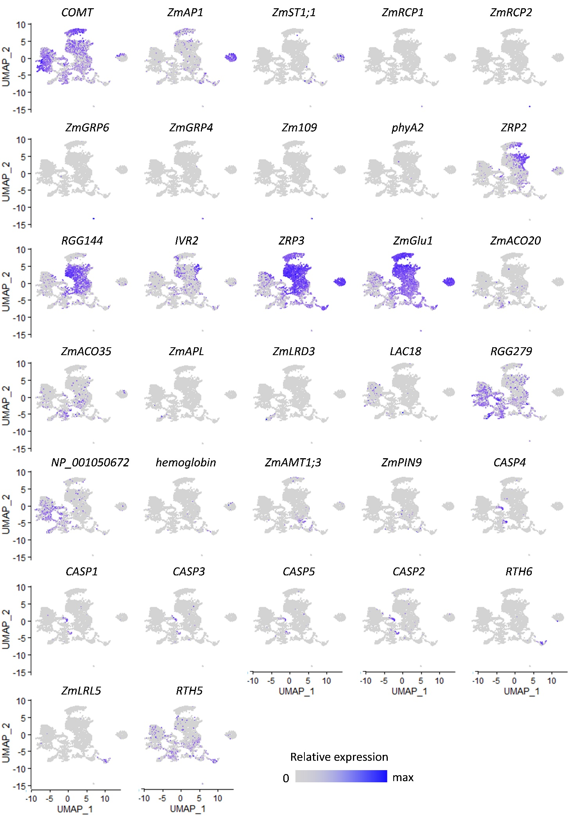

**Fig. S2** – **Scatter plot revealing the expression pattern of known marker genes (as shown in Fig. 1F) used for cell type annotation.**

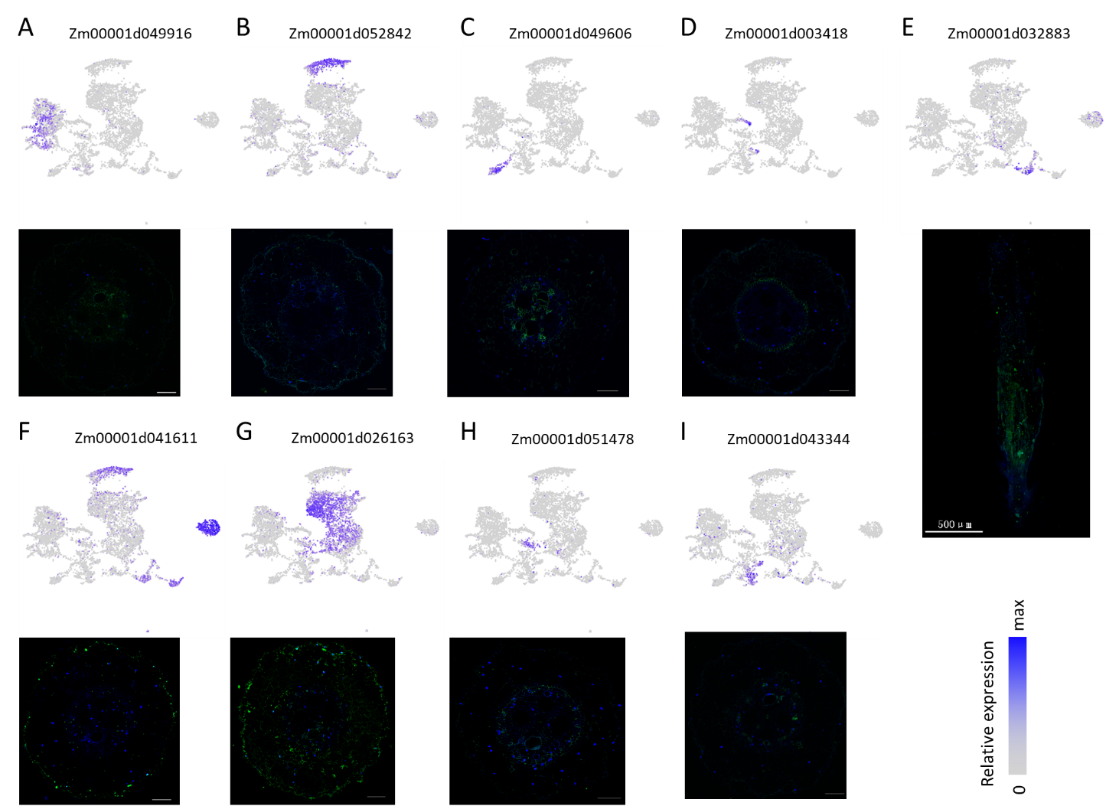

**Fig. S3** – **mRNA fluorescence *in situ* hybridization (FISH) of nine marker genes for corresponding clusters**.

(A) Stele. (B) Exodermis. (C) Protophloem_Sieve. (D) Endodermis. (E) MZ. (F) Epidermis. (G) Cortex. (H) Pericycle. (I) CC. Scale bars, 500 μm for (E), and 100 μm for remaining images. Top, expression of marker genes. Bottom, mRNA FISH in transverse or longitudinal sections of maize root tip. Blue, DAPI for cell nucleus. Green, FAM for mRNA probe.

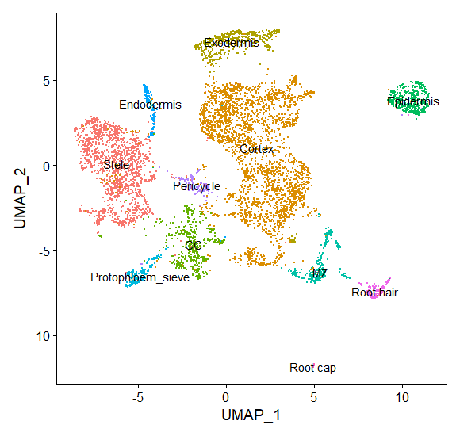

**Fig. S4** – **UMAP visualization for data without cell cycle-associated genes.**

CC, companion cells; MZ, meristematic zone.

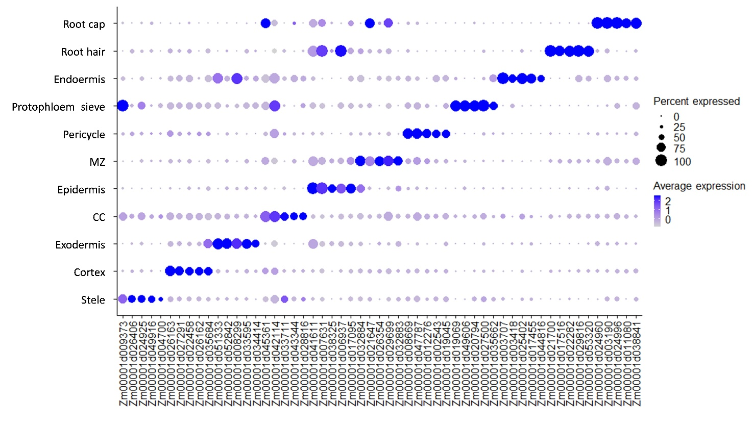

**Fig. S5** – **Expression of top 5 marker genes of each cell type.**

Dot diameter and color indicates proportion of cluster cells expressing a given gene and mean expression across cells in each cluster.

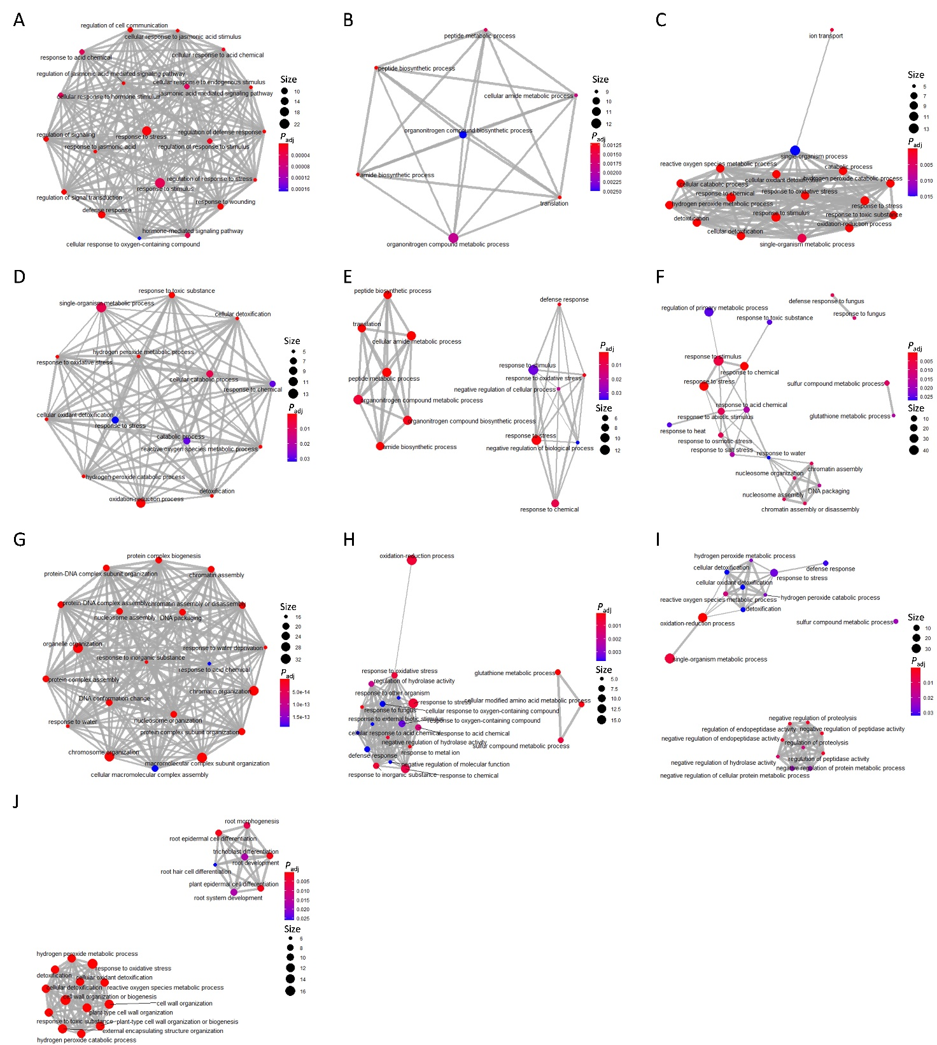

**Fig. S6** – **Network construction based on genes shared between significant GO terms in each cell type or tissue.**

(A) Cortex. (B) Endodermis. (C) Epidermis. (D) Exodermis. (E) Stele. (F) MZ. (G) Pericycle. (H) CC. (I) Root cap. (J) Root hair. Dot size indicates gene number; dot color indicates *P* value; line width indicates genes common to two GO terms.

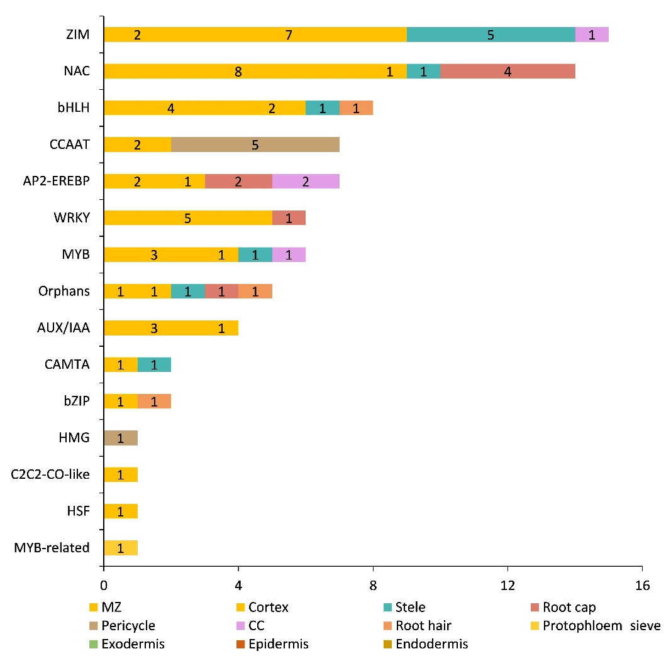

**Fig. S7** – **Statistics of transcription factors across all captured cell types.**

Color in each bar indicate cell types, and number in bar indicate the number of TFs for each cell type.

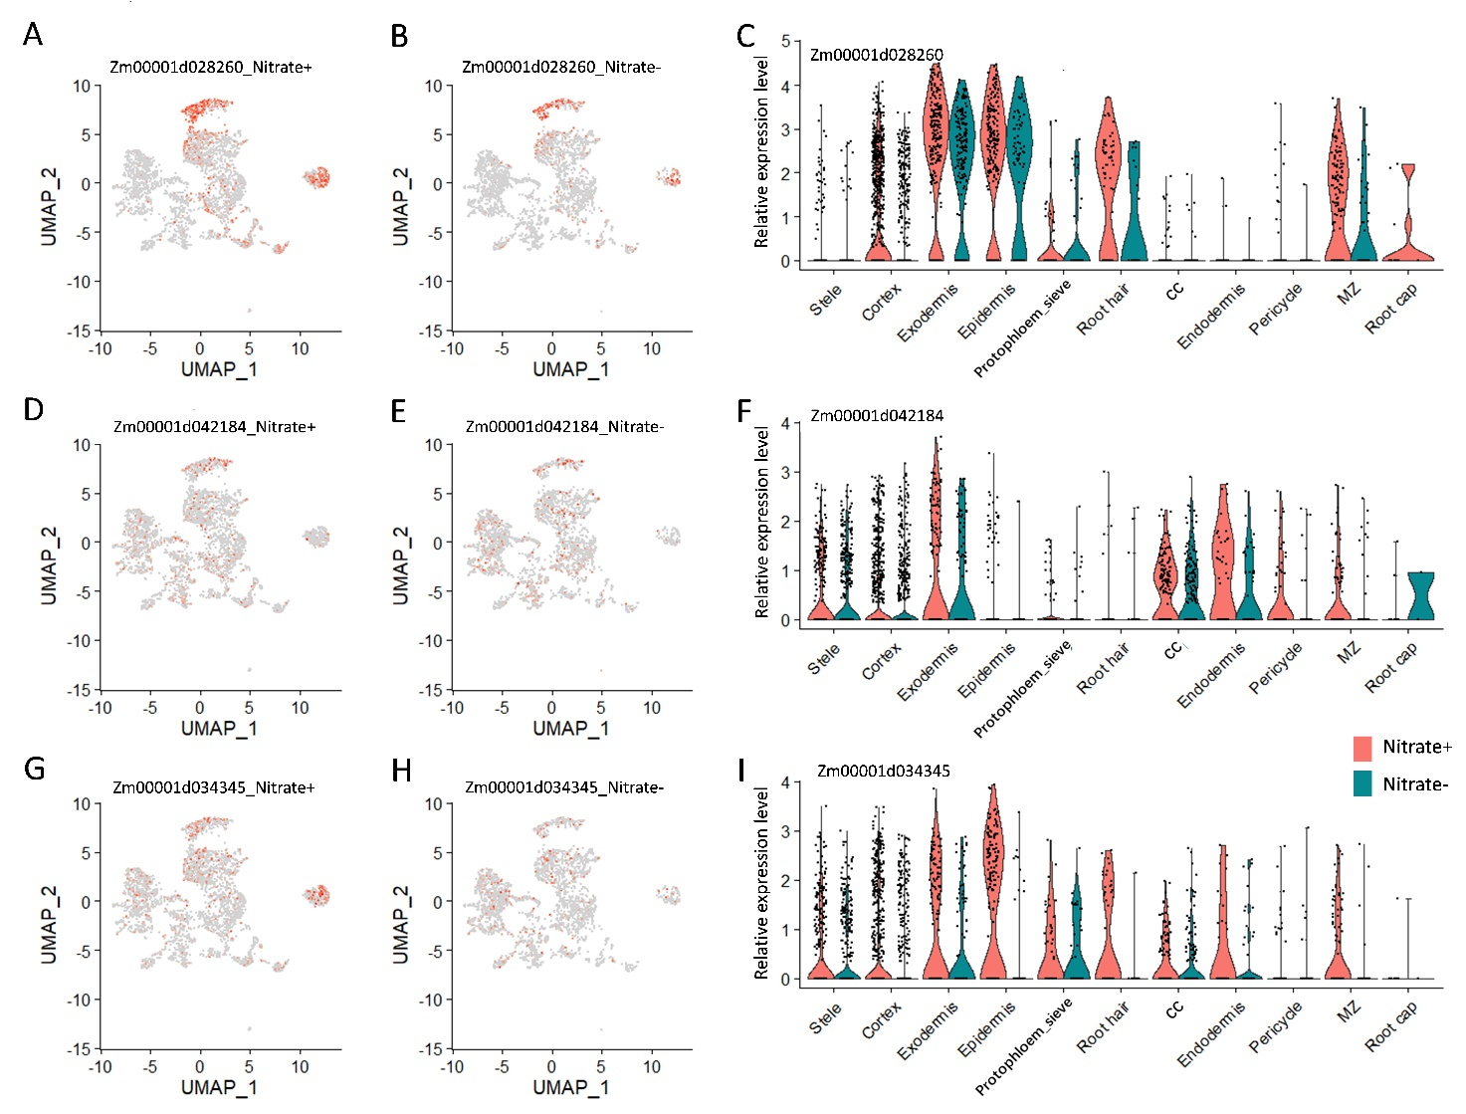

**Fig. S8** – **Expression pattern of genes involved in nitrate metabolism.**

(A–C) Scatter plot showing differential expression of Zm00001d028260 in nitrate+ (A) and nitrate- (B), and violin plot showing gene expression by cell type and treatment (C). (D–F) and (G–I) showing differential expression of Zm00001d042184 and Zm00001d034345, respectively.

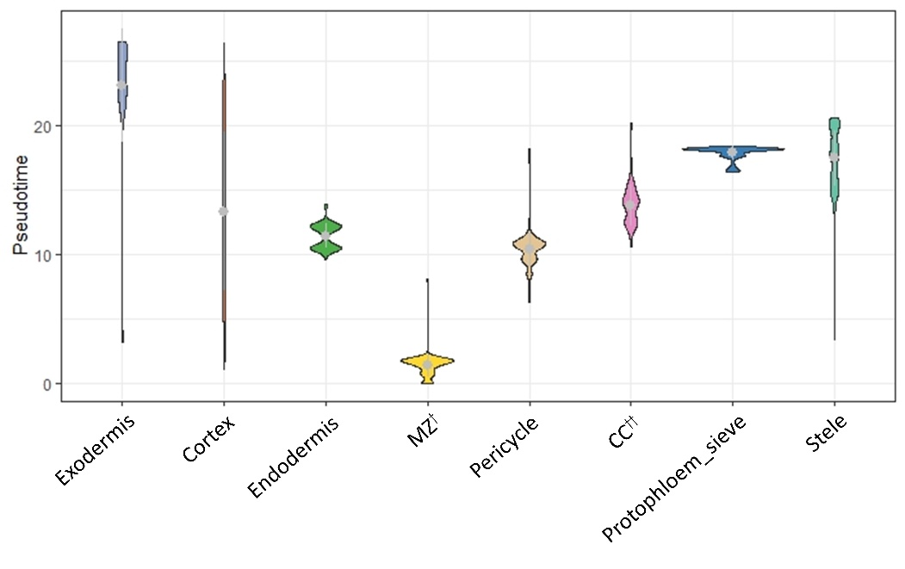

**Fig. S9** – **Violin plot for pseudotime of each cell type or tissue.**

†, Companion cells (CC) associated with the protophloem. ††, Meristematic zone.

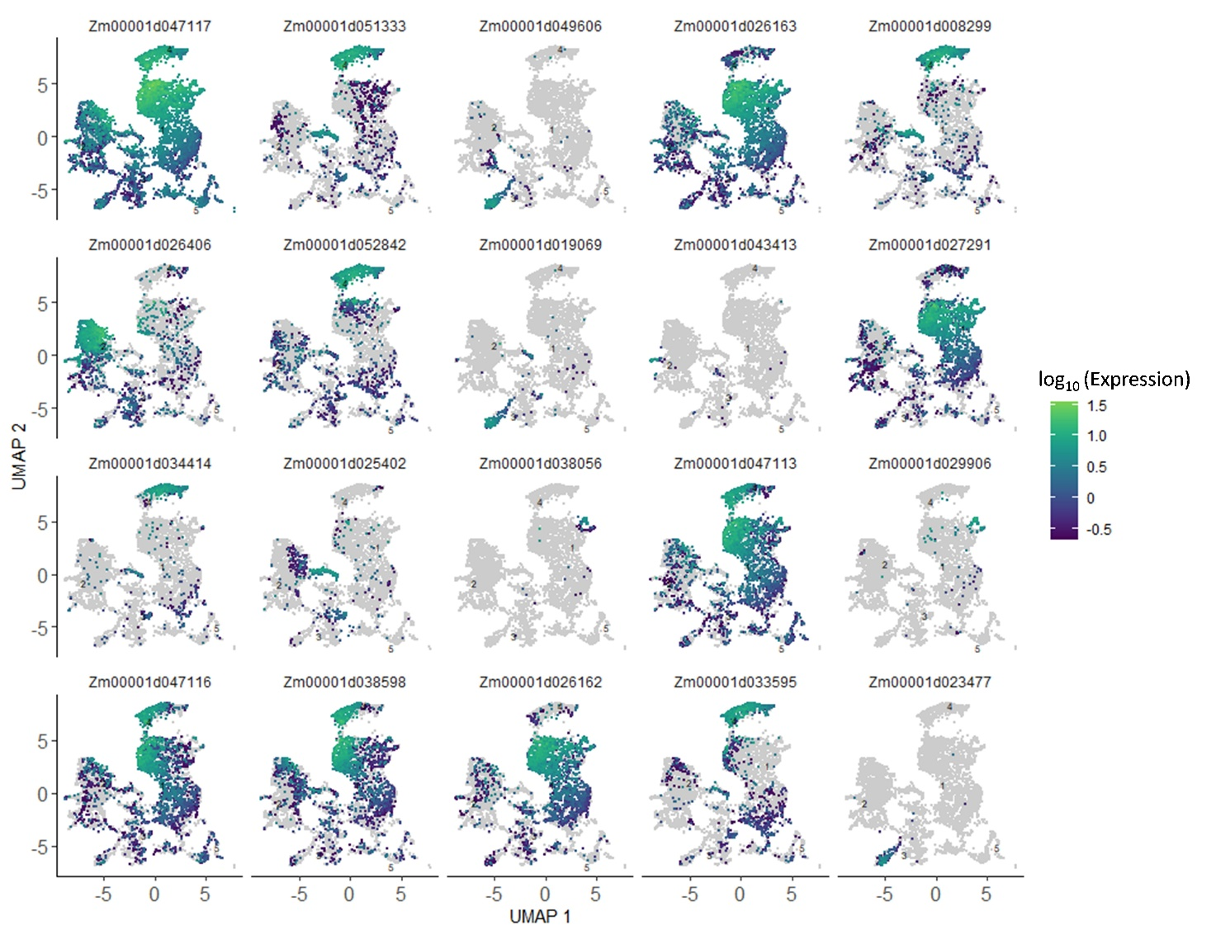

**Fig. S10** – **Expression pattern of top 20 trajectory-dependent genes.**

Dot color indicates the expression of a given gene.

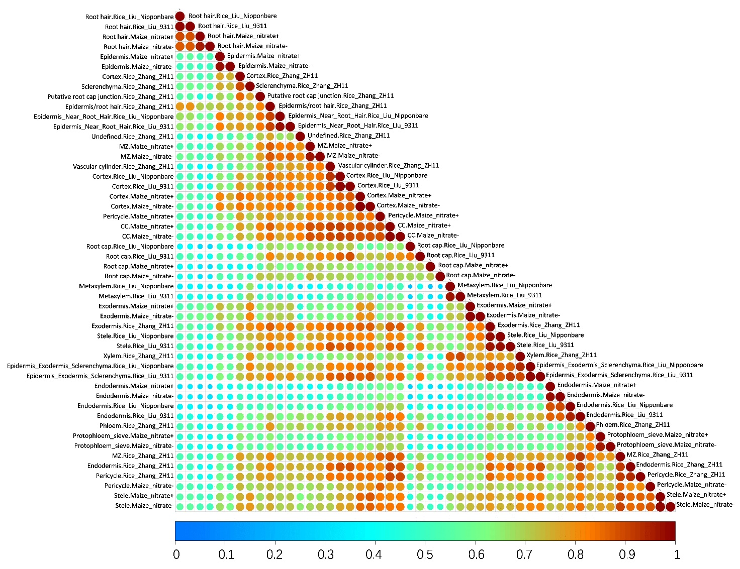

**Fig. S11** – **Heat map showing correlations between cell-type transcriptomes of maize and rice.**

Both dot color and diameter indicate Pearson’s correlations coefficients.

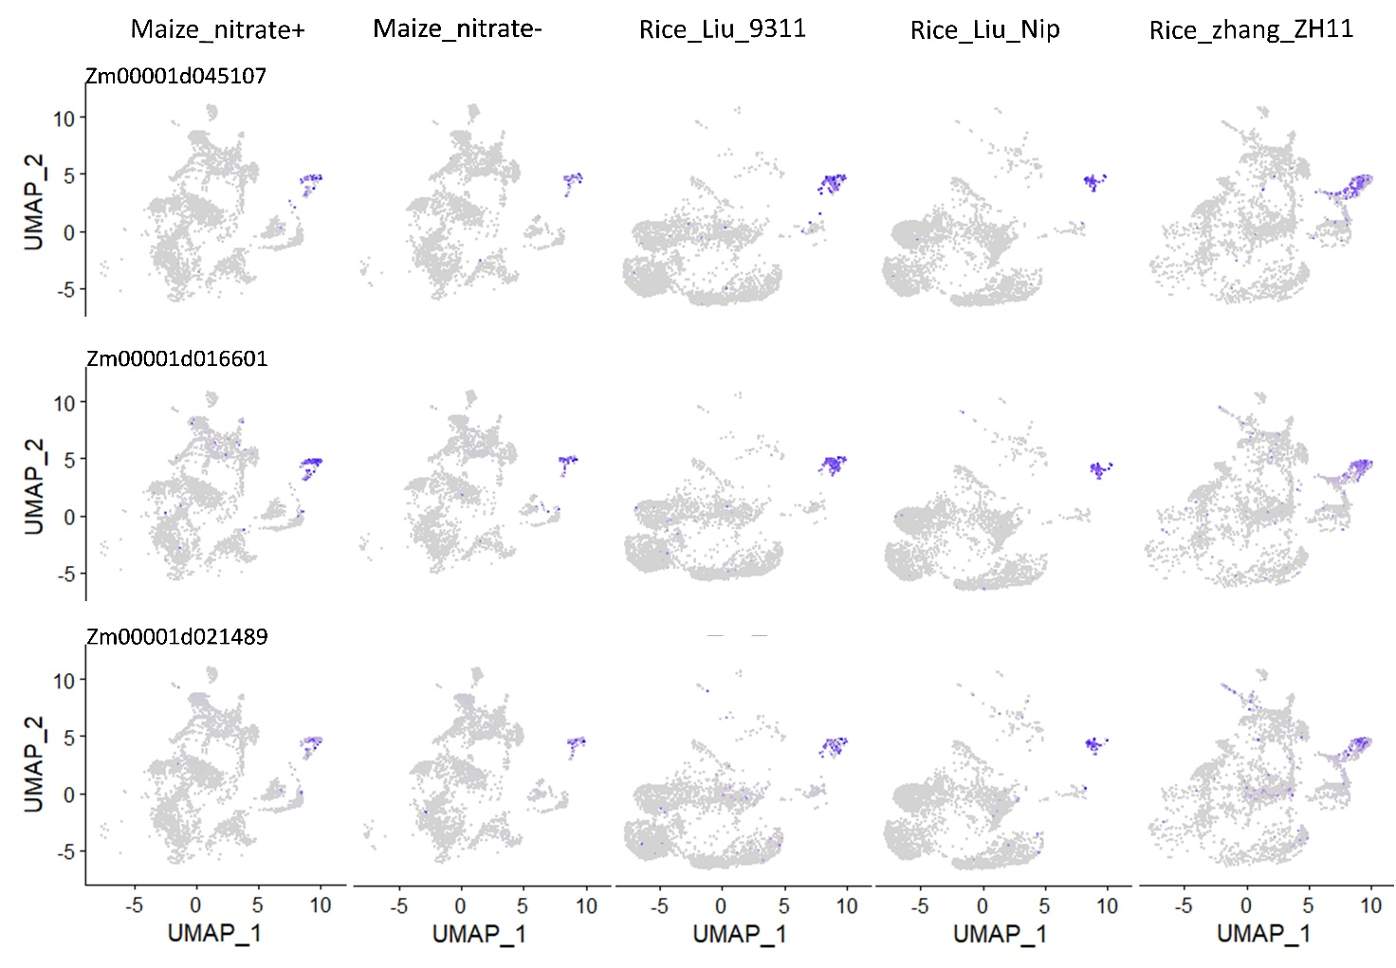

**Fig. S12** – **Expression pattern of three conserved orthologous genes of root hair in maize and rice.**

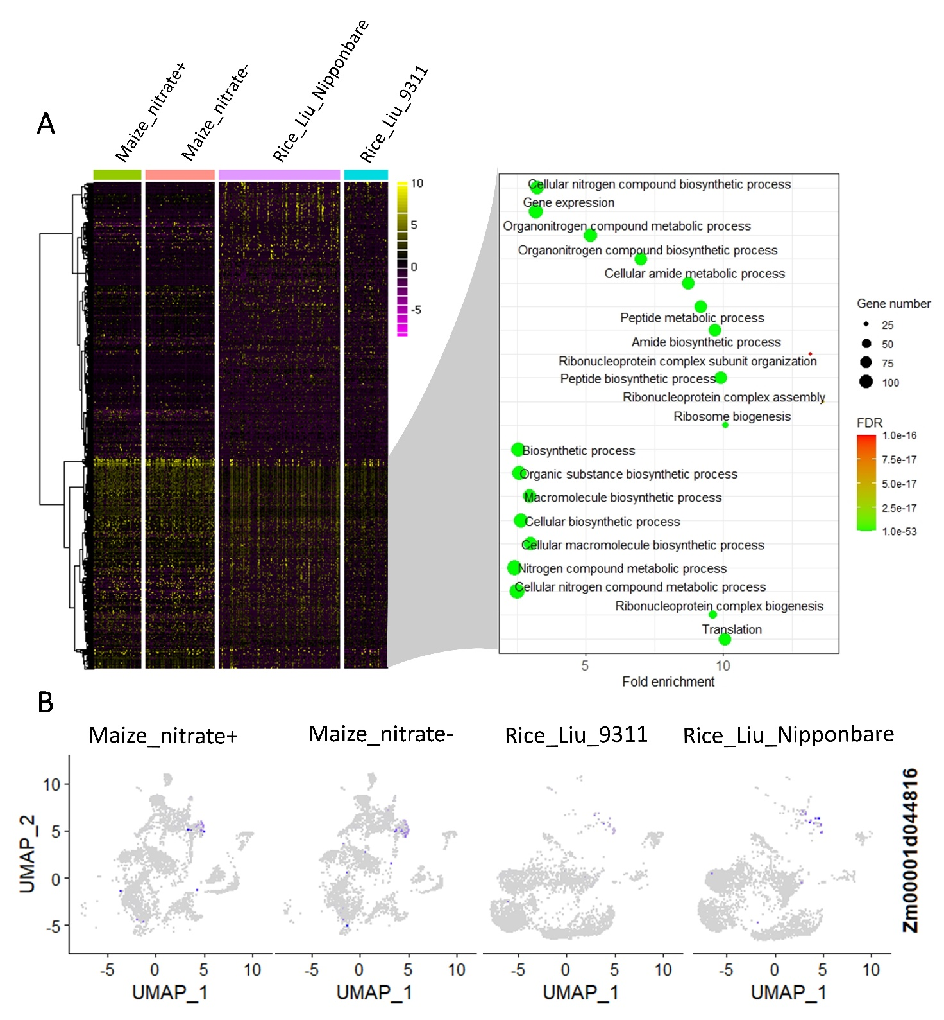

**Fig. S13** – **Identification of genes of endodermis cells conserved between maize and rice.**

(A) Heat map and hierarchical cluster showing the expression of top 500 orthologous genes with the highest variance in endodermis cells, and GO enrichment analysis for conserved orthologous genes between maize and rice. (B) Expression pattern of an example gene that conserved expression across maize and rice.

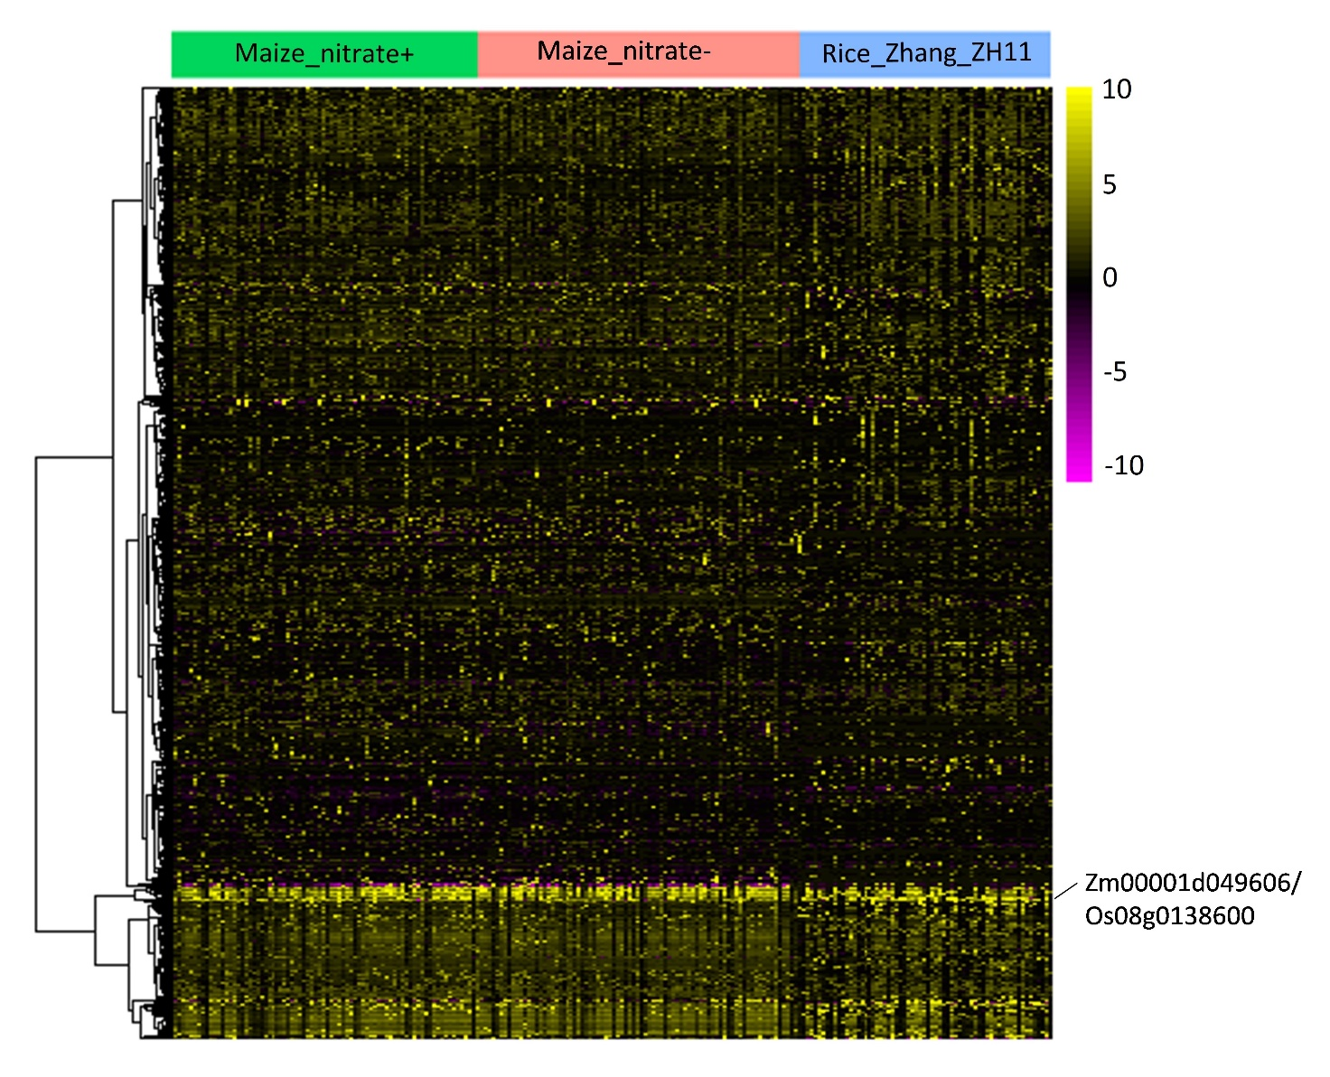

**Fig. S14** – **Heat map and hierarchical cluster showing the expression of top 500 orthologous genes with the highest variance in phloem cells between maize and rice.**